15 years Flemish Sign Language recognition

On the 26th of April 2006 the Flemish Parliament recognized Flemish Sign Language as the visual-gestural language of deaf people in Flanders and Brussels. In 2020 this visual language became more known because of the live press conferences on Covid-19 of the National Security Council. During these press conferences deaf interpreters live interpret to Flemish Sign Language. Clips of these conferences were used in TV news and in that way Flemish Sign Language reached a broad audience.

We wanted to have a big celebration, but Covid-19 prevents us from doing so.

Nevertheless, we are proud and happy to announce three events to celebrate 15 years Flemish Sign Language recognition. One event takes place in Ghent, the other two are held online meaning you can partake from the comfort of your own living room.

DOVEN ZIEN: 16 portraits of signers
22.04 – 02.05.2021 in Museum Dr. Guislain

Sign Language is the most prominent way in which deaf people distinguish themselves from people who hear. Flemish Sign Language was recognized in parliament 15 years ago but is still unknown to many. On this 15 year anniversary sixteen portraits of signers put a spotlight on this special language. The exhibition came into existence through a close cooperation between photographer Benny De Grove, Doof Vlaanderen, Erfgoedhuis Zusters van Liefde JM and Museum Dr. Guislain.

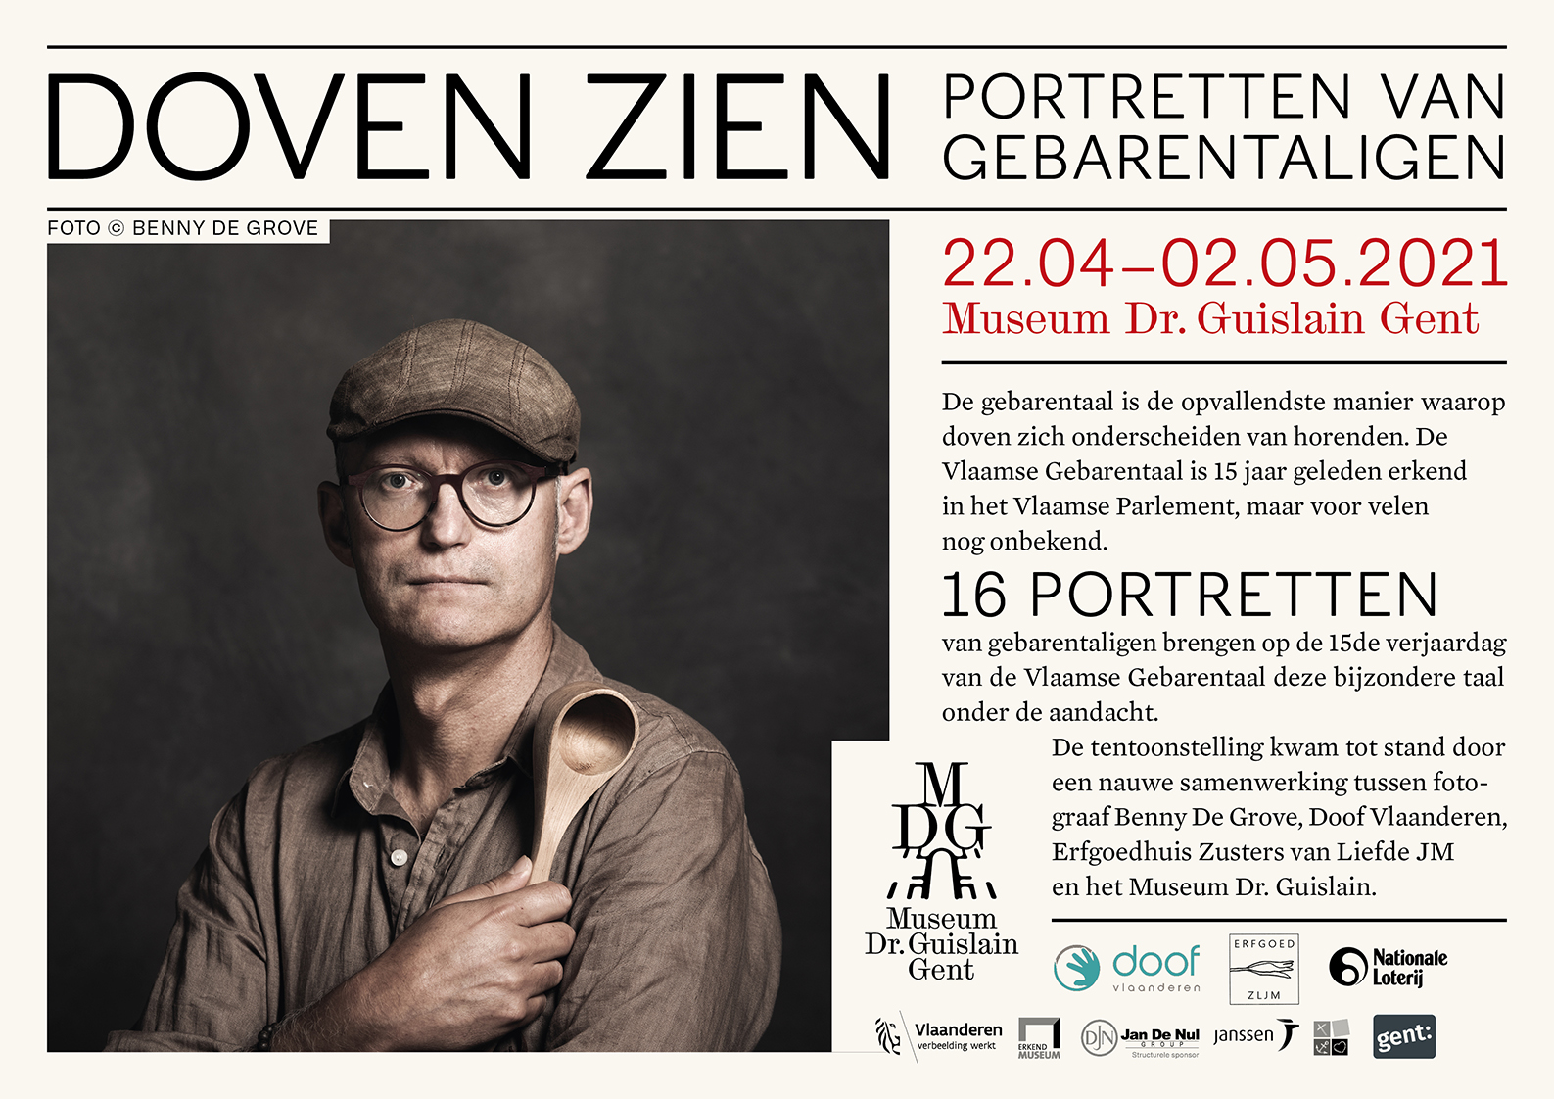

KIJK! POËZIE: a visual poetry collection.
Rhyme through shapes, rhythm through movement.
From 26/04/2021 – online

Many people know that Flemish Sign Language is a real and full-fledged language with its own lexicon and grammar. With this visual poetry collection, we want to show that this visual language lends itself perfectly to poetic use. Instead of sound, metrum and rhythm, we use handshapes, movement, transitions, expression and sometimes even made-up signs.

In cooperation with poëziecentrum Ghent we published the first visual poetry collection. After an interesting set of workshops and coaching, we are proud to show seven poems in Flemish Sign Language.

Online since 26/04/2021: https://www.doof.vlaanderen/poezie

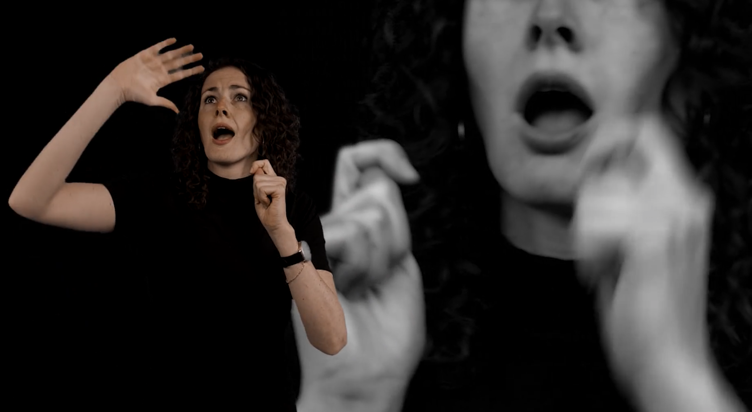
Still from the poem “Corona 2020/21” by Hilde Verhelst

WEBINAR # 15VGT
26/04/2021 at 19u30 – online

Doof Vlaanderen and Vlaamse Gebarentaalcentrum organized a fun webinar of which the live video can be found here: https://www.facebook.com/336086639742557/videos/935429860604866

https://www.facebook.com/events/727495351218320/

